Persistence of Vision on a Bicycle

Nancy Zanaty, Matthew Egan, Gian Thomas, and Sean Schindzielorz

Dept. of Electrical Engineering and Computer Science, University of Central Florida, Orlando, Florida, 32816-2450

Abstract- The ability of the human eye to retain an image for fractions of a second after the image is presented to it is known as Persistence of Vision. This paper describes the creation and manipulation of light-based by spinning LEDs on the wheels of a bicycle. A user interface will allow a person to upload a text image of their choosing, to be displayed on the wheel. The bicycle receives the text image via Bluetooth from the user’s computer, processes it, and displays it as the user is riding. The bicycle is also equipped with a seven-segment display in order to provide the rider with information on their distance traveled, as well as a pedal-operated generator to provide extra power as the user drives the display.

I. INTRODUCTION
The design presented in this paper is that of a Persistence of Vision (POV) bicycle. The intended use of this bicycle is for advertising. As advertisers are always seeking new ways to promote their products and services, there are few ideas more creative than to have an LED display on a bicycle wheel spinning out their logo or company slogan. Having the bicycle receive images wirelessly contributes to the practicality of this idea, as an advertiser would have the freedom to upload and change text images as they pleased without any manual manipulation of the bicycle itself.
Image stability is crucial in this design; it is necessary that any text image displayed on the bicycle wheel be steady and easy to read. For this reason the bicycle is equipped with a Hall Effect RPM sensor which calculates its speed and adjusts the image accordingly. This bicycle consists of five major components: the hardware, the software, the wireless component, the power, and the mechanical design. The design and implementation of each component is examined throughout this paper.

II. PRINTED CIRCUIT BOARD
The Printed Circuit board or PCB can be divided into 3 separate sections or boards. The first PCB is the main PCB which is housed in the wheel of the bicycle. Located on this PCB is the microcontroller, the Hall sensor input, the Bluetooth module, 3 LED drivers and 16 LEDs which are connected to the drivers. The secondary PCB is basically smaller versions of the main PCB. The secondary PCBs however don’t house microcontrollers, hall sensors and Bluetooth modules but they do contain another bank of LEDs and LED drivers. These secondary PCBs connect to the main PCB and provide additional arrays of LEDs for the display. Figure 3 shows this layout of the main and secondary PCBs. The third PCB is located in the handle bar and it houses a micro controller, a Hall Effect input and the 7 segment display, refer to figure 5 for the handle bar PCB.

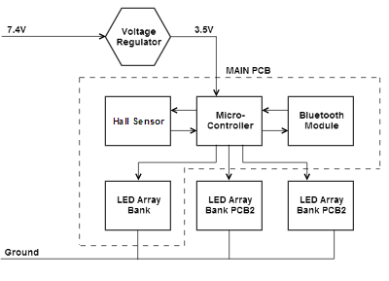 Fig. 1 Setup for the main and secondary PCB.
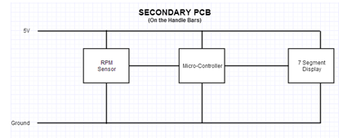
Fig. 2 Schematic for the handle bar PCB.

III. LEDs
We have opted to use common anode, frosted bulb RGB LEDs. The presence of the three colors in the RGB LEDs would allow us to produce a much larger range of colors from a single LED. This large variety of colors would allow for a much better display effect and quality from our POV design. The LEDs would have a frosted bulb because this allows for a much better color dispersion of the light in the individual LEDs, making their mixed colors stand out more. This cuts down on how bright the LEDs can get because of the loss of lumens through the opaque frost. However the frosting also has a great advantage, in that it allows for a much wider viewing angle of the LED. This wide viewing angle would make the POV image visible to more people.
Each of the RGB LEDs has three diodes, which require about 20mA operating. This means each LED should draw at most 60mA when operating.
Additionally, since the LEDs are spinning to produce an image, it is important to ensure that the images are as clear as possible. To avoid streaks or gaps in the images, we have chosen 2mm LEDs in order to keep them as close as possible.

IV. MICROCONTROLLER
We chose the MSP430g2553 for our project. Our reasons for choosing it is because we wanted to pick a microcontroller that would just barely be able to work. For example, some other POV projects use super-fast processors that run at 80 MHz Sure it makes it easier, but we were looking to challenge ourselves. Our microcontroller actually runs at about 16 MHz at maximum. Even this might seem fast for this project, but we still had to do some optimization. As far as the memory goes, we were very uncertain whether it would be enough, but our doubts were in vein, we had more memory than we could ever use. In short, we wanted a processor that wasn’t overkill, but still realistic.

V. LED CONTROLLERS
We chose the TLC5940 LED controller made by Texas Instruments. Our reasons for picking this controller is not as strong, compared to our decision for the microcontroller. But still, it was a decision that needed to be made, and our criteria for doing so, was simply because we already knew how it operated. On the more technical side, it had some features that we liked, such as drive capability, dot correction (which we never took advantage of), and its operating frequency and voltage. In retrospect, this was a very good decision because our project relied heavily on knowing this part.

VI. MICROCONTROLLER PROGRAMMING
There are three major components in code, Sensor detection, message detection (via Bluetooth), and LED updating. Each one comes with its own complication.
Message detection, we send and receive data serially. One of the most important attributes of serial communication is the baud rate. We encountered many errors due to this. The errors were actually integration errors. When Bluetooth was initially tested, we had our microcontroller operating at 1 MHz. Later we realized that was too slow, so we upped it to 16 MHz. By changing the frequency, we changed the baud rate. The testing that led to the solution was mainly trial and error mixed with research. To change the baud rate of an MSP430 isn’t complicated; there are some registers that must be known. Such as, there are two baud rate registers, both in combination divide the clock. When working with just 1 MHz, just one of those baud rate registers were needed, but at 16 MHz, the clock must be divided by much more to achieve the same baud rate, thus more than 8 bits were needed essentially.
Sensor detection was something very new for us. In order to do this, we had to use our microcontroller’s ADC converter and set that pin as an input. In all honestly, this problem was solved mainly by trial and error, and online examples. Once we had done that, it took time to tweak it to exactly what we needed. One interesting thing about obtaining sensor data is that it isn’t just going to set the pin low and work. The voltage on the pin must go through the conversation process. And it won’t do so until we tell it to. What we had to do is, poll the pin and check whether it was low or not. Polling may not seem like the most desirable solution, and it’s probably not. But, in our case we can afford to waste some CPU time doing nothing, so it’s easy yet low risk. We can do this safely because our LED controller function is the only code in our program that is not interrupt driven, so it’s the only pending task. Furthermore, while it’s waiting for the sensor data, we don’t put it into low power mode. The reason for this is mainly due to the mechanics of the code; for the needs of our project it will suffice. The polling actually happens within a while (wait) right before it loads in data to the LEDs. When it detects the sensor it just breaks out, resets the flag, and continues on until it’s waiting again.
Another issue worth mentioning is keeping track of which bit of the data is the most significant. This might seem simple, but there are hidden details that make it complicated. First, there are three points at which the data bits could get reversed. Let’s say we have the color data 0xAC, and for ease of programming we want the left most bit the significant bit. Reversal #1: reverse this raw data and store it. Reversal #2: send each bit one at a time to the LED controller. The easiest way to do this in code is to start with the right most bit (shifting). Each bit must be extracted and sent one at a time. Reversal #3: The LED controller itself is like a shift register in the way it receives data. This way seemed most natural, which means we ended up with fewer errors than we would have otherwise. We could always optimize this further.
The LED updating component is by far the most complicated and is what gave us the most trouble. It has nothing to do with updating the LED’s themselves, that part was fairly straight forward. The complication came with the timing. Timing is merely adding in delays. One use of timing would be to control where on the wheel a message would show up. For example, the delay function might take in a number of degrees as an argument, and then calculate the appropriate time to delay. As far as where this delay would go in code, it would be at the very start of the update LED function. A less obvious use of timing is to control the space between each letter. To visualize this, as the wheel spins faster and faster, the gap between each bar becomes wider and wider. Likewise, when it spins slower, the gap between the letters will be closer. The real problem is calculating how much time to actually spend delaying. In a microcontroller to tell time, what do we have? We have clock cycles, and we know the frequency. Another piece of information we have is the RPM of the tire. With these three things, we should be able to determine how many clock cycles to delay in order to get a stable image. This has yet to be completed, but all the logic has been planned out.

VII. GUI
The purpose of a GUI in our project is to give the user some means of manipulating the hardware, in an easy way. For example, some basic things that a user may want to control are, changing the text displayed, changing the color, and changing the brightness of the LED array. With just these three things, our GUI is not complicated. In order for the user to change the colors, they must merely manipulate three sliding bars, red, green, and blue. The background of the slide bars are colored appropriately, as to avoid cluttering the GUI with text fields. To change the string that’s displayed is also quite easy. It’s just a text input field that requires a string. Changing the brightness is quite easy too. To change the brightness of the LEDs, merely slide the color bar below the maximum value. This feature was actually a pleasant surprise. Using a slide bar is the first/second best way for a user to change the color. The alternative would be using a color wheel. The most immediate advantage to that is that the user can observe the color being mixed, this is an extremely strong advantage, but much harder to do in code. The downside to this is that brightness would need to be controlled separately from color selection, which adds more components and complicates the GUI further. Slide bars are very easy to incorporate, but it’s up to the user to understand the color wheel and mix their colors correctly. Once all this has been done, the upload button still needs to be pressed.
There is a feature that we were unfortunately unable to complete. We had this working graphically, but not logically. Not to make this too complicated, but our GUI should have been able to allow the user to choose how many times the LED array updates during a single tire rotation. There was an actual visual representation of this in our GUI, the data was just never sent.
As far as how we actually made this is pretty simple. Initially we were going to program this in java, and we’re glad we didn’t (We changed from java because there were complications with Bluetooth). What we actually chose was C#. For all the programmers reading this, it’s pretty clear as to why, but simply it’s because in C# GUI’s can be constructed visually. Being able to just drag and drop items into a template and have it fill in the code is very convenient.
As implied, Bluetooth did work in C#. Our Bluetooth chip was plugged into our computer via USB, and windows allowed us to communicate to it serially. This was nice because it allowed us to use all of C#’s .NET serial port libraries and send the data. In the Embedded System lab serial port commination was heavily drilled into us, so it was easy to step up on the microcontroller side too. On the C# side of things there are minor things that should really be done, such as having the user type in the port number to connect to, instead of it being hard coded. We’ve been praising C# this whole time, but it’s by no means perfect. There are some things about C# that are just plain absurd. For example, they for some reason distinguish between characters (non Unicode) and bytes. They are both 8 bits. Yet, if you declare a character you cannot store a hexadecimal value in it! Also, if you declare a byte, you can’t store a character, such as ‘A’ in it. There may be some reason for this. None of us in the group had any prior experience with C#, and even with these annoying flaws, it was definitely worth investing time into. In short, the GUI has a lot of area to improve in, but in the time allocated and for its true purposes, it does exactly what it was meant to do.

VIII. CODE UPLOADING PROCEDURE
In this project, we needed to come up with some way of programming our microcontroller if it was not on the development launch pad that it came with. At first this was a very real concern, since we had absolutely no experience doing it. There were factors we weren’t sure of, one in particular was just forgetting how memory worked, which is pretty silly.
The question was, would disconnecting the microcontroller from the launch pad erase its program memory? If it did, it would have been a pretty big problem, but after realizing how flash memory worked it was pretty clear it was okay.
The next issue we faced was how we were going to program the microcontroller after it had been soldered. We had to figure out which pins were actually needed to program it. Once these pins were known, the PCB design could include easy access to them. The way we determined which pins were needed was solely on trial and error. We determined that trial and error was actually a fairly fast way to approach this problem because there were only 3 possible pins that would be involved in the programming. The controller has 20 pins, 14 are I/O, VCC, and ground. The remaining 4 pins were XIN, XOUT, TEST, and RST. Clearly, RST would be needed to program the microcontroller, so our three pins to experimentally test were, TEST, XIN, XOUT, thus 6 possibilities. The case was that only two pins were necessary for programming and they were RST, and TEST. The TEST pin is most likely used for the IDE’s debugger mode.

IX. EXTRA CODE INFORMATION
This section is unfortunately about parts of our project that we would have liked, but did not end up doing. Right now our device can display text; we really wanted to incorporate pictures as well. Pictures and text have some similar problems. First of all, when displaying text, let’s say we have a very long string, 100 characters long for our message. To display all 100 of these characters it would clearly wrap around the wheel a couple times over, so we would have squeeze these letters very close together. Okay, so let’s now assume that we’ve crunched these letters so close together that they occupy exactly one rotation. At this very point, there are two points of concern in the code.
Problem 1, we don’t use enough delay and the text actually ends up using slightly more than one rotation. In this case, an entire frame would be skipped. If the code is simple, and it only displays text when the sensor is tripped, then the sensor would be triggered twice during one display routine, thus that second trigger would not actually trigger the next sequence.
Solution, there are two solutions to this problem that we think are worth investing thought into. The first solution is, when the sensor is triggered for the second time, have it break out of its current display routine and start over, so part of the message may be cut short, this has obvious downsides. Solution 2, put in a large enough delay to guarantee the message will always occupy less than one rotation.
Problem 2, this problem is the other half of the spectrum of when the message takes up exactly one rotation, solution 2 of the previous problem would have a greater effect on this. When dealing with text, having the entire message cut short is more than likely no big deal. However, when it comes to images, we want the edge between the start and end to be as seamless as possible. So the problem is simply, a blank gap would form.

X. BLUETOOTH
Bluetooth was chosen for this project because it required very low power and was straightforward to implement on the chosen microcontroller. Bluetooth also allowed for easy paring with a variety of common devices including computers and cell phones.
A Bluetooth module based on the HC-06 was selected for this project after comparing several common modules. The module has already contained everything needed to establish a connection including an antenna and integrated Bluetooth stack. The module was easy to connect to using the msp430’s UART interface, and it was very low cost.

XI. 7-SEGMENT DISPLAY
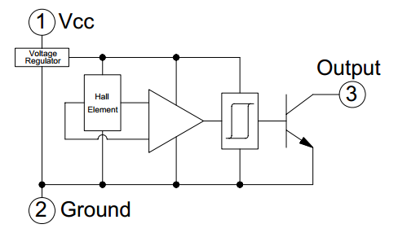
It was decided that the project would use a 7-segment display to show relevant information to the user from the handle bars of the bike. This display shows information regarding distance traveled. A 7-segment display fit this role very well because it is easily viewed in direct sunlight, has wide viewing angles, requires very little power, and is very light weight. Common Anode 7-segment LEDs were used. They require significantly less power from the microcontroller to drive because the controller only needs to sink the required current.
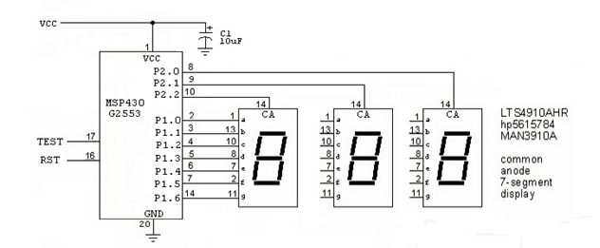
Fig. 3. 7-Segment Display Schematic
The 7-segment LEDs were wired in parallel and time division multiplexed as shown in Figure 1. Information regarding the rider’s distance was calculated using the following formulas;
- The first mode will record the total distance traveled according to the following equation:
$$D=Revolution*Wheel Circumference$$
- The second mode will reset the display

XII. RPM SENSING
There is an important need for finding out the rotational speed of the wheels. With the use of this speed we can calculate the timing of the LEDs to produce a stable and complete display, as well as display back to the rider their distance traveled. Since the rotational speed or RPM of the wheels of the bicycle is so important, there was need for an accurate yet small, and simple means to measure the RPM.
A Hall Effect sensor was chosen as the RPM sensor. The sensor is easily mountable, it is very durable and very accurate. The Hall Effect sensor chosen is the OHN3019U. This sensor is set up as a reed switch in that as it come close to the threshold magnetic field flux (300 Gauss) [1] it drops this output voltage to 0V. This provides a digital signal to time the rotation of the wheels. From figure 2, the hall sensor has a built in hysteresis triggering circuit to improve the sensing accuracy.

Fig. 4. The internal IC of the OHN3019U Hall Effect sensor.

XIII. POWER
As many of the components in the design require the proper power supply to operate, this is a critical part of the project design. Powering the POV display is perhaps one of the greatest challenges of this project, as it requires not only determining the accurate voltage and current input for each element of the bicycle, but also ensuring that the power sources are safe and reliable.

A. Battery
The main power source comes from a 4.0Ah 7.4V Lithium Nickel Manganese Cobalt Oxide battery (LiNiMnCoO₂) or NMC battery. These batteries display very high specific energies and are the batteries of choice for many power tools and a wide range of electric vehicle applications. Our chosen battery has a built in protection IC to prevent over-charging and over-discharging.

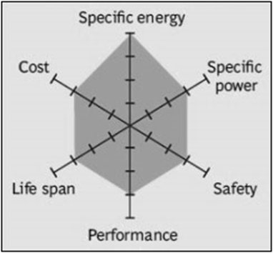

Fig. 5 A web chart of the strengths and weaknesses of LiNiMnCoO2 batteries. [2].

The NMC battery supplies 7.4V to both the back wheel which houses the main POV LEDs and control center as well as the Bluetooth module receiver. The battery also provides power to the handle bar display. Voltage regulators (LM317 adjustable voltage regulators) are used to step down the DC voltage to about 3.5V which is the typical operating voltage of all of the components on the bicycle.

B. AC-to-DC-Converter
Having all components running would eventually deplete the battery and so to charge the battery an AC-DC charger has been built and should charge the battery from depleted to full in about 3.5 hours. The AC-DC charger employs a step down transformer and a full bridge wave rectifier as well as a LM317 voltage regulator to turn 120VAC to 8V DC (Figure 2). The voltage regulator helps in ripple rejection of the signal and also helps us maintain constant charging voltage.
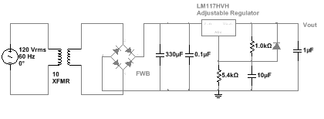
Fig. 6 . AD-DC charger circuit.

The battery would need to be removed from the bicycle to be charged with the AC-DC charger, however while riding the battery would be charging via the generator which would supply up to 3.75W of power. The generator would allow for supplemental charging while on the go.

C. Generator
While the components of the POV display such as the LEDs, wireless transceivers, and seven-segment display will be powered primarily through the DC battery, the idea of the design is to have a bicycle that a user can ride around for a reasonable amount of time. Thus, it is ideal to have a backup source such that the user can continue to ride with an active display even after the main power source runs low. For this reason we opted to use a pedal-operated generator which is capable of providing extra power. We have chosen the Human Creations Bicycle Dynamo USB Charger. This generator is designed for the purpose of charging a cell phone or any other USB-connected device. In our case, instead of charging a cell phone, this connection would be used to charge a battery pack on the bicycle. This generator provides different outputs of current based on the speed of the bicycle. The speed to current relationship is shown in Fig. 7.

Speed (mph) | Charging electric current (mA)
5.3 | 100
5.9 | 150
6.5 | 200
8.4 | 250
9.3>=12.4 | 300>=500

Fig. 7. Speed-to-current relationship of the generator

D. Testing

Testing the reliability of the power sources of the hardware components of the POV bicycle is one of the most important aspects of this project. There were several tests performed for each power aspect of the display:
- Battery Endurance Testing- Battery endurance testing was to examine how long the batteries powering the POV display would last under certain loads. To do this, we first simulate the battery and several loads in NI Multisim. That gave us our expectations for how much power should be delivered to each component after battery adjustments are made. Knowing this information, we can measure and test how long the battery lasts while it’s operating at several different loads. We will measure the battery life when all hardware components of the POV bicycle are in full operation.
- Generator Testing - First, in order to ensure that the expected current outputs of the generator match the expected outputs for each bicycle speed, we run the bicycle at different speeds (as determined by the RPM sensor). Using a multimeter, we measure the current being output by the generator at each speed, and compare it to the expected value. If the current output is drastically different than what was expected, then we know that the generator may be defective. Second, we compare the current at different radial speeds (revolutions per second). Understanding how the current output changes as the bicycle speed increases or decreases allows us to approximate the ideal speed of the bicycle for solid performance and reliability of the display.
- Battery Charging Testing- We will measure how long it takes for the battery to charge. The primary battery will be connected to the AC power source while a multimeter measures the voltage across the connected load to determine how long it takes for the battery to reach its maximum voltage.

XIV. MECHANICAL DESIGN
The physical components of the PVC system were mounted on the following bicycle locations:
- The Secondary Display (7-segment) and phone charger were mounted on the handle bars.
- The LEDs with their corresponding controllers were mounted in the spokes of the rear wheel.
- The ring connector was attached to the hub of the rear wheel.
- The brush connector and generator were attached to the frame of the bike near the rear wheel.
- The battery was mounted towards the center of the bike on the frame.
To get power from the battery, mounted to the bikes frame, to the microcontroller, located inside the rotating bike wheel, some kind of rotating connector was needed. After going through several preliminary designs a working connector was developed based on the same carbon brushes that are common in many car alternators. The PCBs inside the rotating wheels were grounded to the bike’s axle. This meant that the connector only needed to carry power.
The rotating component of the connector is made of a PVC ring with foam insulation attached to the sides to isolate it from the wheel’s spokes. A copper ring was bonded to the ring using solder. Wires were run through a hole on the inside of the PVC ring to the copper ring. The ring connector was then physically attached to the bike’s wheel around the rear axle. An alternator brush housing was mounted to the bike frame near the center of the rear wheel. The two carbon brushes make contact with the copper on the PVC as the wheel turns. Springs under the brush maintain constant pressure to ensure that electrical contact is always maintained. This is illustrated in Figure 2.
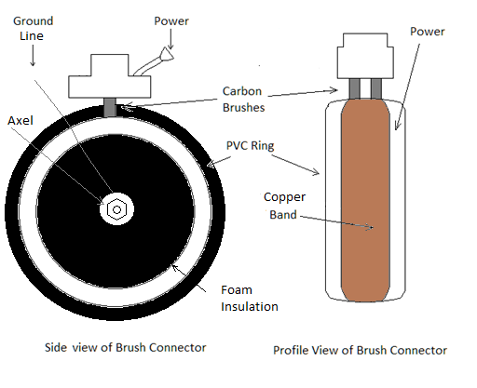
Fig. 8. Brush Connector Schematic

XV. CONCLUSION
This paper describes the design and implementation of a persistence of vision (POV) bicycle display. The project consists of a hardware component such as the printed circuit board; the software component which includes all of the back end coding for the display; the wireless communication which operates via Bluetooth to allow a user to change the image on the bicycle display remotely; the power component which consists of batteries and generators working together to keep the bicycle display alive; and the mechanical design which allows the components to come together and work in harmony for one effective display.

XVI. PROJECT ENGINEERS


Sean Schindzielorz is a senior engineering student at the University of Central Florida. He will graduate in May 2014with a degree in Computer Engineering (B.S.Cp.E). He plans to continue his education in the field of computer engineering, as well as beginning a career in industry.


Gian Thomas is a senior engineering student at the University of Central Florida. He will receive his degree in electrical engineering (B.S.E.E.) in May 2014. Mr. Thomas Plans to pursue a Master’s degree in the near future, in a field related to EE.


Matthew Egan has been programming for 5 years. He hopes to find a job after graduation and save his money. His interests are vast, and is always trying to improve.



Nancy Zanaty is a senior engineering student at the University of Central Florida. She will graduate in May 2014 with a degree in Electrical Engineering (B.S.E.E.). After graduation, she plans to enter industry and begin her career as a semiconductor process engineer.

ACKNOWLEDGEMENT
Boeing has been a long-time supporter of engineering education and provides a great deal of support to students at the University of Central Florida. Each year, Boeing encourages the creative thinking and development of engineering students by providing sponsorship for several Senior Design projects.
Our team had the opportunity to receive funding from Boeing through our university by offering them a proposal with our project objectives and budget.
Boeing’s funding has covered the majority of the expenses of this project, and any additional costs were self-funded. Their contribution is indispensable, and we are extremely grateful for their generosity.

REFERENCES

- Meyer, A. (2011, July 5). A Strange Attraction. Various Hall Effect Sensors. Retrieved October 20, 2013, from http://bildr.org/?s=hall+effect
- Lechnyr, D. (2003, July 30). Types of Batteries. Retrieved October 25, 2013, from http://www.tldp.org/HOWTO/Battery-Powered/battery.htm

